Created By: Suresh Adhikari

Date : 12/10/2017

# Merge Output

**Main Class:**

MergeInputMainClass.java

* It will read inputs from Console
* We can give number of rows and columns for the 2D array
* It will return result in the console

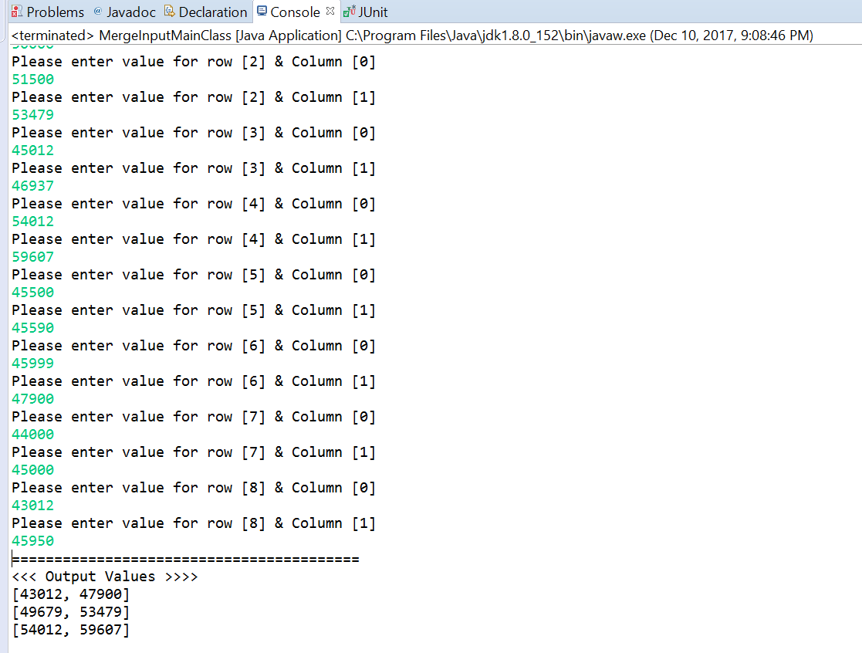

**Junit Test Class:**

*MergeValuesTest.java*

* *Input is hardcoded*
* *Desired output is hardcoded*
* *We compare the desired output with the actual output.*
* *If result matches, test case passes otherwise it fails.*
* *Please find the attached snapshot below*

***Printing values in console:***

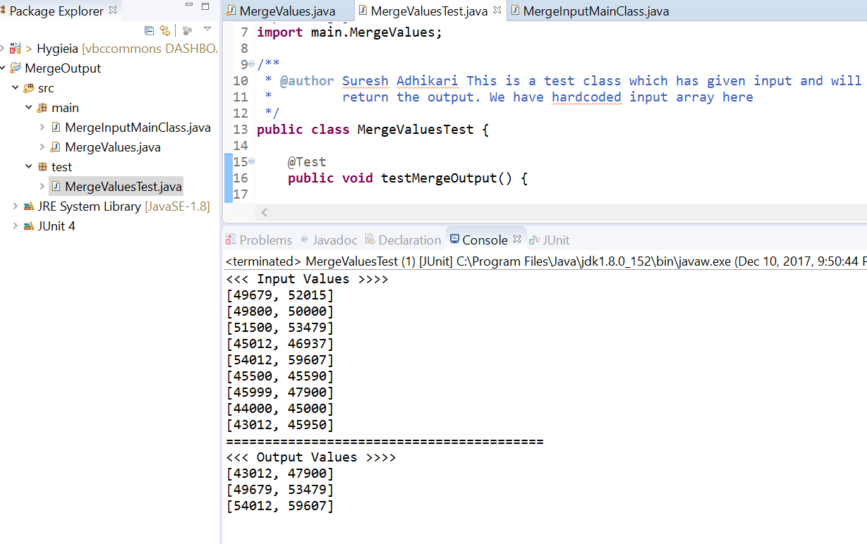

**Junit Test Case Report:**

